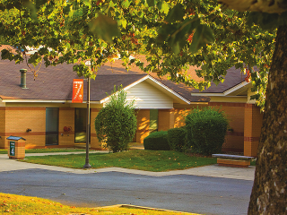

**Lunch will be provided**

**12:00 - 1:30 p. m.**

**Youth Opportunity Center**

**Drive # 1**

**Thursday, November 19**

## YOC “Behind the Scenes”

## The Youth Opportunity Center is home to over 140 kids (ages 6-18) residing in nine residential cottages, on the 75-acre campus located in Delaware County.

## Do you know what goes on behind the scenes at YOC?

## The YOC would like to share with you about the children and families we serve. We would like to show you our facilities, share stories about the children we have impacted.

## YOU are invited to attend our “Behind the Scenes” lunch and learn conducted by volunteer board members and staff. As a friend, donor or colleague we hope that you will join us for lunch and learn more about the YOC and YOC Foundation.

**Contact Genet Soule**

[**gsoule@yocinc.org**](mailto:gsoule@yocinc.org)

**RSVP Requested by:**

**Tuesday, November 17**